The Commonwealth of Massachusetts
Executive Office of Health and Human Services
Department of Public Health
Bureau of Health Professions Licensure
Drug Control Program
239 Causeway Street, Boston, MA 02114
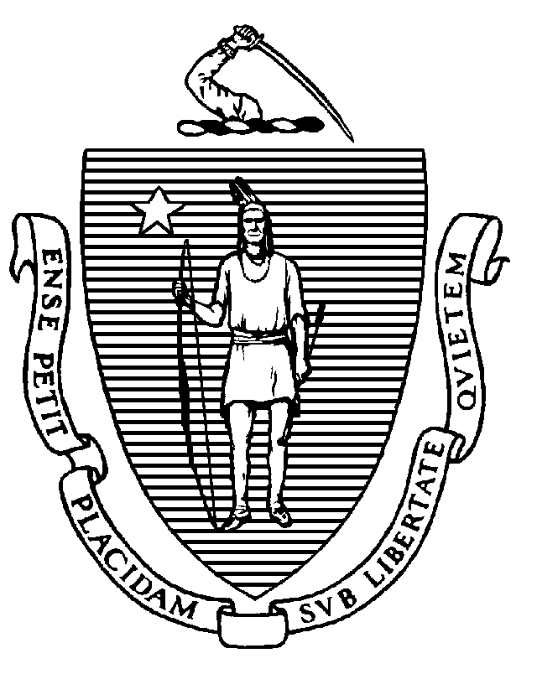
CHARLES D. BAKER
Governor
KARYN E. POLITO
Lieutenant Governor
MARYLOU SUDDERS
Secretary
MONICA BHAREL, MD, MPH
Commissioner

Tel: 617-624-6000
www.mass.gov/dph

NOTICE

From: Department of Public Health, Medication Administration Program (MAP)
To: MAP Administrators and Coordinators
Date: June 15, 2021
Subject: OTC Method B – Remote verification by licensed professionals

In light of COVID-19 and associated social distancing guidance, several Medication Administration Program (MAP) sites are continuing to engage in telehealth, rather than having licensed professionals attend these sites in-person in non-emergent circumstances.

For sites that use Method B to facilitate administration of over-the-counter (OTC) medications and preparations, MAP Policy 06-6 Over-the-Counter Medications and Preparations includes requirements for a licensed professional to provide in-person verification.

To address this particular need and provide available flexibility, the Department of Public Health’s Drug Control Program and MAP are extending the authorization for sites without non-emergent, in-person licensed professionals to employ telehealth for this verification step for 90 days. Specifically, the following alternative verification procedures are authorized until September 15, 2021:

Policy 06-6 (2)(b)(iii)-(v): A licensed professional can compare the manufacturer’s label to the Health Care Provider order and verify the contents of the OTC or preparation via photos and phone communication or video communication with MAP Certified staff. Pursuant to the licensed professional’s comparison and verification, MAP Certified staff may:
- initial the container;
- place the name of individual(s) on the container; and
- place the date of verification on the container.

