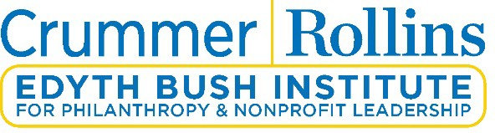

December 13, 2021
Dear Valued Community Partner,
Founded in 1973, the Edyth Bush Institute for Philanthropy & Nonprofit Leadership (EBI) began as a nonprofit resource and mentorship service as part of the Edyth Bush Charitable Foundation. Over the years, EBI has expanded to now serve nonprofits throughout Florida and Georgia. In every relationship, EBI has stayed true to continually strengthen the impact, effectiveness and leadership of nonprofit and philanthropic organizations delivering quality education and management assistance.
EBI is very pleased to announce a special scholarship opportunity for six individuals to receive support for eighteen credit hours associated with a certificate from Edyth Bush Institute for Philanthropy & Nonprofit Leadership (EBI). The eighteen hours must be expended by May 31, 2022. This generous offer made possible by the Heart of Florida United Way (HFUW), is intended to help individuals build capacity and skillsets related to nonprofit service. The HFUW is committed to offering continuous support in the fight for the overall stability of every person in Central Florida.

The following criteria must be met to be considered for certificate workshop training made possible by the HFUW:

- Organization must reside in Orange, Osceola and/or Seminole county.
- Organization must have an annual operating budget of $500,000 or below.
- Organization must serve the ALICE (Asset Limited, Income Constrained, Employed) population. More information can be found on the HFUW’s website at https://www.hfuw.org/meetalice/.
- Preference will be given to individuals serving nonprofits whose clientele are primarily underrepresented groups, minorities, or communities of color.
To be considered, the individual applying must:
- Confirm application criteria is met through the completed application below
- Commit to complete 18 hours of training towards an EBI certificate program no later than May 31, 2021
*All application materials should be sent to Jim Moody at jmoody@rollins.edu .

The selection of individuals will begin with an application review. Based on written applications, EBI will provide a recommendation to the HFUW, who in turn will make the final decision regarding awarded individuals.
We are delighted to offer this opportunity in partnership with the Heart of Florida United Way. If I can be of assistance during the application process, please do not hesitate to contact me.
Sincerely,

Jim Moody Program Manager
(407) 975-6417
jmoody@rollins.edu

Edyth Bush Institute Application Form
Certificate Workshop Training Scholarship Opportunity

Individual Name: _______________________________________________________________________________
Organization Name:

Organization Address:

County:

Phone Number:

Website:

Executive Director:

Your Email Address:

Mission
Statement:

Budget Size:

Please outline the year your organization was founded, a short description of your nonprofit foundation and history, and a description of client demographics served by the organization.

Please describe how your programs and services meet the ALICE population and particularly, underrepresented groups, minorities, and/or communities of color.

Please describe which EBI certificate you wish to pursue and why.

Please describe how certificate workshop training will enhance you and your organization’s needs?

