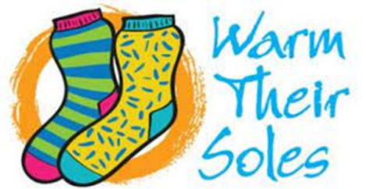

UWGB Phi Kappa Phi Honor Society sponsors Toasty Toes Sock Drive for our Afghan friends
What: Toasty Toes Sock Drive for Afghan refugees at Fort McCoy
When: November 22nd through March 1st
How: Drop NEW socks in bins. (Men’s, Women’s and Children’s needed)
Why: Let’s help those who helped us!
Where: Drop in the PKP Toasty Toes bins-four UWGB campus locations

Campus Bin Locations
Green Bay | Marinette | Sheboygan | Manitowoc
Garden Café (near ATM) | Main Lobby | Student Services | Main Lobby F119
Cofrin Library (near the Learning Center) | Library Lobby
Rose Hall second floor(outside Rooms 220 & 230)
GBOSS
Theatre Hall/Studio Arts entrance
Afghanistan refugees began arriving at Fort McCoy in late August. Now numbering nearly 13,000, most arrived with only the clothes they were wearing during the long journey. Help Phi Kappa Phi provide socks to so many in need this winter. We welcome your generous donations of NEW pairs of socks at our four UWGB campus bin locations. Help us warm hearts and toes!

