**Test Results**

Respirators help protect against certain particulate contaminants but do not eliminate exposure to or the risk of contracting any disease or infection. Misuse of a respirator can result in exposures that can result in sickness or death.

The test results below indicate the performance of the filtration material specific to the respirator tested. The materials were tested using specialized equipment and protocols, similar but not equivalent to the NIOSH standard procedure TEB-APR-STP-0059; reported filtration efficiencies may differ accordingly. These results do not guarantee that all respirators produced by a manufacturer will have a similar level of filtration efficiency or a similar level of resistance to fluid penetration. These results do not imply a fitness for a particular use or compliance with any federal or international standards. These respirators were not tested in an accredited National Institute for Occupational Safety and Health (NIOSH) testing laboratory, and thus are not NIOSH approved or certified. We have worked with the Advanced Functional Fabrics of America, Inc. (AFFOA) to obtain respirator performance characterization. AFFOA coordinated testing at MIT Department of Chemical Engineering and MIT Lincoln Laboratory where comparable conclusions about mask quality were obtained. The Filtration efficiency measurements listed below were taken by the Massachusetts Institute of Technology. The resistance to fluid penetration measurements below were taken by MIT Lincoln Laboratory.

According to [ASTM F 1862,](https://www.fda.gov/regulatory-information/search-fda-guidance-documents/surgical-masks-premarket-notification-510k-submissions#7) surgical masks are tested on a pass/fail basis at three velocities corresponding to the range of human blood pressure (80, 120, 160 mm Hg). Fluid resistance may be claimed if the device passes ASTM F1862 at the corresponding level. Surgical masks that show passing results at higher velocities are more fluid resistant. The test results below indicate the performance of the specific mask tested.

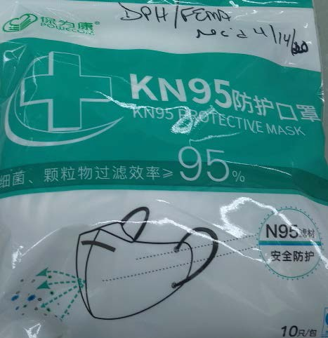

POWECOM

Test date – 4/18/20 - Filtration efficiency: 90.6% Test date – 4/17/20 – Filtration efficiency: 92 %

[Visit CDC website for additional information on this](https://www.cdc.gov/niosh/npptl/respirators/testing/NonNIOSHresults.html)  [product](https://www.cdc.gov/niosh/npptl/respirators/testing/NonNIOSHresults.html)

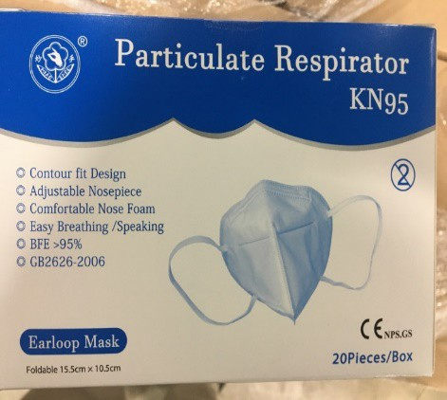

|  |  |
| --- | --- |
|  | Jiangsu Nanfang Medical CO. LTD  Test date – 4/17/20 – Filtration efficiency: 90.3% Test Date – 4/24/2020 – Penetration Resistance Test: Passed High Standard (Level 3, 160mmHg); no soak through |
|  | Foshan Wei hui Labor Protection Products Co., Ltd Test date – 4/17/20 – Filtration efficiency: 84.2% Test Date – 4/24/2020 – Penetration Resistance Test: Passed High Standard (Level 3, 160mmHg); no soak through, but partial layer penetration along seams |
|  | Unlabeled – plastic bag with KN95 on the mask  Test date – 4/17/20 – Filtration efficiency: 28.1% |
|  | KN-95 Disposable Face Mask  Test date – 4/16/20 – Filtration efficiency: 52.3% Test Date – 4/27/2020 – Penetration Resistance Test: Passed High Standard (Level 3, 160mmHg); no soak through, but partial layer penetration along seams |
|  | SHUYIAN  Test date – 4/16/20 – Filtration efficiency: 87.6% |

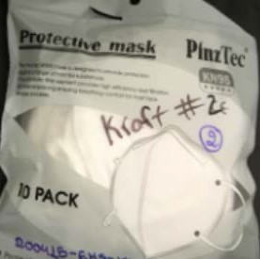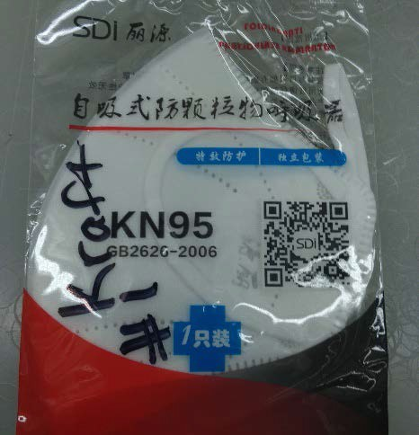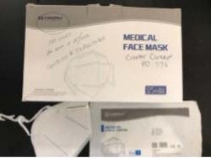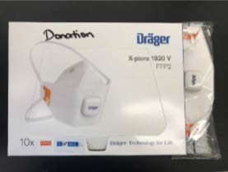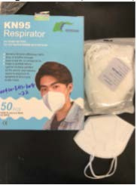

|  |  |
| --- | --- |
|  | PinzTec  Test date – 4/16/20 – Filtration efficiency: 83.6% |
|  | SDI Folding Anti-Particulate respirator  Test date – 4/16/20 – Filtration efficiency: 91.4% |
|  | ESOUND Med  Test date – 5/18/2020 – Filtration Efficiency: 96.4%  Test Date – 4/29/2020 – Penetration Resistance Test: Passed High Standard (Level 3, 160mmHg); no soak through |
|  | Drager  Test date – 4/24/2020 – Filtration efficiency: 95% Test Date – 4/29/2020 – Penetration Resistance Test: Passed High Standard (Level 3, 160mmHg); no soak through |
|  | AOXING  Test date – 4/24/2020 – Filtration efficiency: 87.8% Test Date – 4/27/2020 – Penetration Resistance Test: Passed High Standard (Level 3, 160mmHg); no soak through, but partial layer penetration along seams |

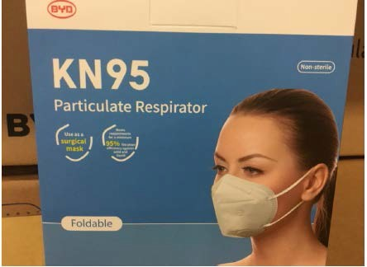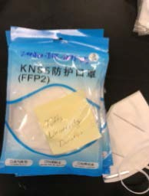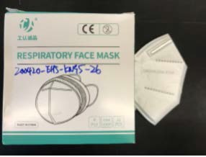

|  |  |
| --- | --- |
|  | Dasheng Model DTC3X  Test Date – 4/24/2020 – Filtration efficiency: 88.7% Test Date – 4/27/2020 – Penetration Resistance Test: Passed High Standard (Level 3, 160mmHg); no soak through  [Visit CDC website for additional information on this](https://www.cdc.gov/niosh/npptl/respirators/testing/NonNIOSHresults.html)  [product](https://www.cdc.gov/niosh/npptl/respirators/testing/NonNIOSHresults.html) |
|  | Americares Emergency Response BYD CARE  Test Date – 4/24/2020 – Filtration efficiency: 89% Test Date – 4/29/2020 – Penetration Resistance Test: Passed High Standard (Level 3, 160mmHg); no soak through |
|  | KN95 (FFP2)  Test Date – 4/24/2020 – Filtration efficiency: 70% Test Date – 4/29/2020 – Penetration Resistance Test: Failed |
|  | GONGRENCHENGPING  Respiratory Face Mask  Test Date – 4/24/2020 – Filtration efficiency: 85.9% Test Date – 4/27/2020 – Penetration Resistance Test: Passed High Standard (Level 3, 160mmHg); but partial layer penetration along stitches |
|  | LVJIANGNAN  Test Date – 4/24/2020 – Filtration efficiency: 91.4% Test Date – 4/27/2020 – Penetration Resistance Test: Passed High Standard (Level 3, 160mmHg); no soak through |

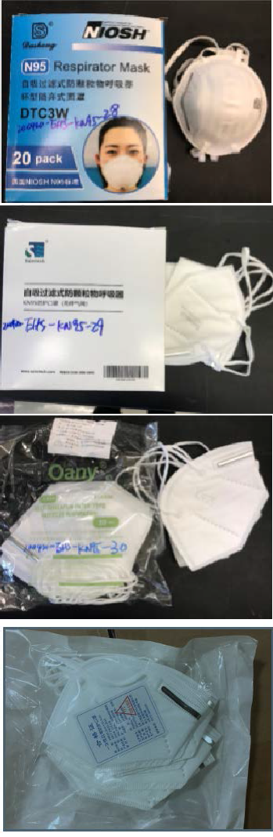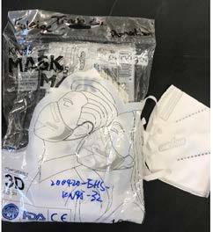

|  |  |
| --- | --- |
|  | DASHENG MODEL DTC3W  Test Date – 4/26/2020 – Filtration efficiency: 91.8% Test Date – 4/27/2020 – Penetration Resistance Test: Failed |
|  | Saiertech  Test Date – 4/26/2020 – Filtration efficiency: 85.9% Test Date – 4/27/2020 – Penetration Resistance Test: Passed High Standard (Level 3, 160mmHg); no soak through, but partial layer penetration along seams |
|  | OANY  Test Date – 4/26/2020 – Filtration Efficiency: 62.3% Test Date – 4/29/2020 – Penetration Resistance Test: **Failed** |
|  | Gerber Outerwear (White Packaging)  Test Date – 5/27/2020 – Filtration efficiency: 83.4% Test Date – 4/29/2020 – Penetration Resistance Test: Passed High Standard (Level 3, 160mmHg); no soak through |
|  | PURVIGOR  Test Date – 4/27/2020 – Filtration efficiency: 73.4% Test Date – 4/29/2020 – Penetration Resistance Test: Passed High Standard (Level 3, 160mmHg); but partial layer penetration along stitches  [Visit CDC website for additional information on this](https://www.cdc.gov/niosh/npptl/respirators/testing/NonNIOSHresults.html)  [product](https://www.cdc.gov/niosh/npptl/respirators/testing/NonNIOSHresults.html) |

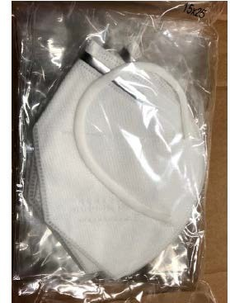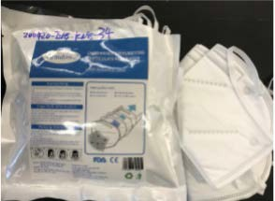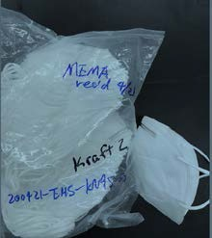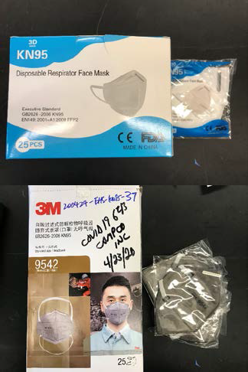

|  |  |
| --- | --- |
|  | JCH Industrial, Hong Kong  Test Date – 4/27/2020 – Filtration efficiency: 86.7% Test Date – 4/29/2020 – Penetration Resistance Test: Passed High Standard (Level 3, 160mmHg); but partial layer penetration along stitches |
|  | Lamdown  Test Date – 4/27/2020 – Filtration efficiency: 87.4% Test Date – 4/27/2020 – Penetration Resistance Test: Passed High Standard (Level 3, 160mmHg); but partial layer penetration along stitches |
|  | N/A  Test Date – 4/27/2020 – Filtration efficiency: 62.6% Test Date – 4/29/2020 – Penetration Resistance Test: **Failed** |
|  | Yiwu Hongbiao Garments Co. Ltd  Test Date – 4/29/2020 – Filtration Efficiency: 91.1%  Test Date – 4/24/2020 – Liquid Penetration Test: Passed |
|  | 3M KN-95 Campco, Inc.  Test Date – 4/29/2020 – Filtration Efficiency: 95.6%  Test Date – 4/24/2020 – Liquid Penetration Test: Passed |
|  | Makrite  Test Date – 4/26/20 – Filtration Effeciency: 91.6%  Test Date – 4/25/2020 – Liquid Penetration Test: Passed |
|  | Safe Secure  Test Date – 4/29/2020 - Filtration Efficiency: 89.8%  Test Date – 4/24/2020 – Liquid Penetration Test: Failed, MP 1 /2 soak through in main body when pressed with swab |
|  | GB2626-2006 KN95  Test Date – 4/29/2020 - Filtration Efficiency: 78.9%  Test Date – 4/25/2020 – Liquid Penetration Test: Passed |
|  | PM 2.5, 5-pack  Test Date – 4/29/2020 - Filtration Efficiency: 73.20%  Test Date – 4/25/2020 – Liquid Penetration Test: Passed |
|  | HG, 5-pack  Test Date – 4/29/2020 - Filtration Efficiency:51.10%  Test Date – 4/25/2020 – Liquid Penetration Test: Passed |
|  | ONE MIX  Test Date – 4/29/2020 - Filtration Efficiency:85.3%  Test Date – 5/18/2020 – Filtration Efficiency: 85.9%  Test Date – 4/27/2020 – Liquid Penetration Test: Passed |
|  | Huran  Test Date – 4/29/2020 - Filtration Efficiency:93.00%  Test Date – 4/27/2020 – Liquid Penetration Test: Passed |
|  | Ace Neale  Test Date – 4/29/2020 - Filtration Efficiency: 92.0%  Test Date – 4/28/2020 – Liquid Penetration Test: Passed |
|  | Guan Hua Item 9801  Test Date – 4/29/2020 - Filtration Efficiency:84.7% |
|  | Linxia  Test Date – 4/29/2020 - Filtration Efficiency:89.2% |

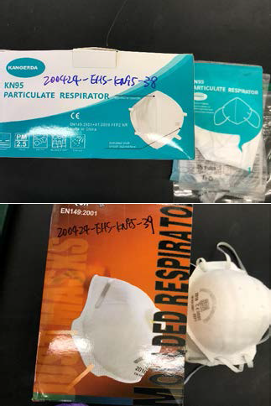

|  |  |
| --- | --- |
|  | KANGERDA  Test Date – 4/29/2020 – Filtration Efficiency: 70.5%  Test Date – 4/24/2020 – Liquid Penetration Test: MP, HP ½ soak through center seam when pressed with swab |
|  | DROMEX (Campo Inc.)  Test Date – 4/30/2020 – Filtration Efficiency: 80.9%  Test Date – 4/24/2020 – Liquid Penetration Test: Passed |
|  | S. Sansgo  Test Date – 4/30/2020 – Filtration Efficiency: 90.0% |
|  | ZHIYI  Test Date – 5/5/2020 – Filtration Efficiency: 82.4 %  Test Date – 5/4/2020 – Liquid Penetration Test: Liquid Penetration Test: Failed LP 1 /2 oak through at center seam HP 1 /2 almost soak through at center seam |
|  | Chun Lam Group  Test Date – 5/5/2020 – Filtration Efficiency: 86.0%  Test Date – 5/5/2020 – Liquid Penetration Test: Passed |
|  | DR. MFYAN  Test Date – 5/5/2020 – Filtration Efficiency: 45.5% %  Test Date – 5/5/2020 – Liquid Penetration Test: Liquid Penetration Test: Failed partial penetration through outer layers |
|  | ALLMAN  Test Date – 5/5/2020 – Filtration Efficiency: 92.4 %  Test Date – 5/5/2020 – Liquid Penetration Test: Passed |
|  | Doctor Hua (Jiayuan Technology)  Test Date – 5/5/2020 – Filtration Efficiency: 63.4 % Test Date – 5/5/2020 – Liquid Penetration Test: Passed |
|  | Shenzhen Zhiyou  Test Date – 5/5/2020 – Filtration Efficiency: 61.8%  Test Date – 5/5/2020 – Liquid Penetration Test: Passed |
|  | Shanghai Huaxiang Woolen Dressing  Huaxiang Woolen  Test Date – 5/5/2020 – Filtration Efficiency: 84.1 %  Test Date – 5/5/2020 – Liquid Penetration Test: Passed |
|  | China Southern  Test Date – 5/5/2020 – Filtration Efficiency: 72.8 %  Test Date – 4/22/2020 – Liquid Penetration Test: Liquid Penetration Test: HP 1/2 soak through in main body of filter when pressed with swab |
|  | Ocean State Donation  Test Date – 5/5/2020 – Filtration Efficiency: 86.0 % |
|  | FFP2 NK International (King Year Printing &  Packaging Co. Ltd.)  Test Date – 5/5/2020 – Filtration Efficiency: 75.4%  Test Date – 5/26/2020- Filtration Efficiency: 81.7%  Test Date - 4/22/2020- Penetration Resistance: Passed; no soak through, but some penetration along the stitching |
|  | Model:YH006 (Joint China Ltd.)  Test Date – 5/5/2020 – Filtration Efficiency: 81.6%  Test Date – 5/5/2020 – Liquid Penetration Test: Passed |
|  | BIWEIKANG  Test Date: 5/8/2020 – Filtration Efficiency: 85.5% |
|  | Easewell (Easepal Ind. Co. Ltd.)  Test Date: 5/8/2020 – Filtration Efficiency: 81.7%  Test Date – 5/4/2020 – Liquid Penetration Test: Passed |
|  | Makrite (SEKURA)  Test Date: 5/8/2020 – Filtration Efficiency: 92.6%  Test Date – 5/8/2020 – Liquid Penetration Test: Passed |
|  | EATA  Test Date: 5/8/2020 – Filtration Efficiency: 73.2%  Test Date – 5/4/2020 – Liquid Penetration Test: Passed |
|  | Uniair (SAN HUEI United Co. Ltd)  Test Date: 5/8/2020 – Filtration Efficiency: 88.9%  Test Date – 5/8/2020 – Liquid Penetration Test: Passed |
|  | Xier  Test Date: 5/12/2020 – Filtration Efficiency: 62.0%  Test Date – 5/12/2020 – Liquid Penetration Test: Passed |
|  | Spectrum 50-pack  Test Date: 5/12/2020 – Filtration Efficiency: 72.5%  Test Date – 5/11/2020 – Liquid Penetration Test: Passed |
|  | San Huei United Co., Ltd. SH9550  Test Date: 5/12/2020 – Filtration Efficiency: 86.4%  Test Date – 5/12/2020 – Liquid Penetration Test: Passed |
|  | In Jeolly  Test Date: 5/12/2020 – Filtration Efficiency: 83.4%  Test Date – 5/12/2020 – Liquid Penetration Test: Passed |
|  | Fujian Meinkind Baby Products, Ltd  Test Date: 5/12/2020 – Filtration Efficiency: 71.1%  Test Date – 5/12/2020 – Liquid Penetration Test: Passed |
|  | 50 pack donation  Test Date: 5/12/2020 – Filtration Efficiency: 91.1% |
|  | Aumacom  Test Date: 5/12/2020 – Filtration Efficiency: 48.5% |
|  | XAM-Med  Test Date: 5/12/2020 – Filtration Efficiency: 85.7% |
| C:\Users\swhite\AppData\Local\Microsoft\Windows\Temporary Internet Files\Content.Word\20200513_103712.jpg | ANHUIYAXIA Anhui Yaxin Plastic  Test Date: 5/20/2020 – Filtration Efficiency:85.0%  Test Date – 5/20/2020 – Liquid Penetration Test: Passed |
|  | MINGCAI  Test Date: 5/20/2020 – Filtration Efficiency: 61.0%  Test Date – 5/20/2020 – Liquid Penetration Test: Passed |
|  | Benehal Suzhou Sanical Benehal  Test Date: 5/20/2020 – Filtration Efficiency:85.0%  Test Date – 5/23/2020 – Liquid Penetration Test: Failed, soak through at center seam |
|  | China Etech  Test Date: 5/20/2020 –  Small Font Filtration Efficiency:86.1%  Large Font Filtration Efficiency: 87.0% |
| **C:\Users\swhite\AppData\Local\Microsoft\Windows\Temporary Internet Files\Content.Outlook\3YHDUN2W\IMG_1164.jpg** | AM – AiMei  Test Date: 5/20/2020 – Filtration Efficiency: 81.6% |
|  | Gansu Newshanyou  Test Date: 5/20/2020 – Filtration Efficiency: 59.7%  Test Date – 5/20/2020 – Liquid Penetration Test: Passed |
|  | HY - Hunan Huanyu  Test Date: 5/20/2020 – Filtration Efficiency: 54.5%  Test Date – 5/20/2020 – Liquid Penetration Test: Passed |
|  | ESound Med, “N-95”  Test Date: 5/29/2020- Filtration Efficiency: 97.19% |
|  | Donation, 30 pack  Test Date: 4/22/2020- Filtration Efficiency: 92.3% |
|  | Sky Screen, Box of 20  Test Date: 4/22/2020- Filtration Efficiency: 98.8%  Test Date – 4/22/2020 – Liquid Penetration Test: Passed |
| **C:\Users\swhite\AppData\Local\Microsoft\Windows\Temporary Internet Files\Content.Outlook\3YHDUN2W\IMG_1086.jpg** | Donation, 2-pack  Test Date: 5/11/2020- Filtration Efficiency: 77% |
| **C:\Users\swhite\AppData\Local\Microsoft\Windows\Temporary Internet Files\Content.Outlook\3YHDUN2W\IMG_1099.jpg** | Guo Xiang, 3 pack  Test Date: 5/11/2020- Filtration Efficiency: 82.1%  Test Date – 5/12/2020 – Liquid Penetration Test: Failed soak through at center seam |
|  | Hong Jie, Box of 10  Test Date: 5/11/2020- Filtration Efficiency: 81.3%  Test Date – 5/11/2020 – Liquid Penetration Test: Passed |
|  | King Fa  Test Date: 5/11/2020- Filtration Efficiency: 87.4% |
| **Spectrum 1-pack** | Spectrum, 1-pack  Test Date: 5/11/2020- Filtration Efficiency: 76.6%  Test Date – 5/11/2020 – Liquid Penetration Test: Passed |
|  | Face Code, package of 10  Test Date: 5/23/2020, Filtration Efficiency: 86.3%  Test Date – 5/23/2020 – Liquid Penetration Test: Passed, but front is absorbent |
| **C:\Users\swhite\AppData\Local\Microsoft\Windows\Temporary Internet Files\Content.Outlook\3YHDUN2W\IMG_1141.jpg** | Fujian Pageone, Package of 5  Test Date: 5/23/2020,  Filtration Efficiency, 87.5%-99%  Test Date – 5/23/2020 – Liquid Penetration Test: Passed |
|  | Fujian Pageone, Package of 5, Marked “Non-Medical”  Test Date@ UML: 1/10/2021:  Filtration Efficiency 93.26%-96.89%  Liquid Penetration Test: Passed  Test Date @ MIT: 1/10/2021  Filtration Efficiency: 98.3%-99.5% |
|  | Shenzen YiFan, Package of 5  Test Date: 5/23/2020, Filtration Efficiency: 55.2%  Test Date – 5/23/2020 – Liquid Penetration Test: Passed |
|  | Shenzen YiFan, Package of 5 (Version B, different packaging)  Test Date: 6/23/2020, Filtration Efficiency: 86.4%  Test Date – 6/23/2020 – Liquid Penetration Test: Passed |
|  | Etech, Box of 50  Test Date: 5/18/2020, Filtration Efficiency: 86.1%  Test Date – 5/18/2020 – Liquid Penetration Test: Passed |
|  | Zhong Yi, Box of 20  Test Date: 5/26/2020, Filtration Efficiency: 98.9% |
|  | Reis, Pack of 5  Test Date: 5/18/2020, Filtration Efficiency: 82.1%  Test Date – 5/18/2020 – Liquid Penetration Test: Passed |
| cid:image001.jpg@01D62DEE.0AC33540 | Dasheng (green box, Model DTC3X), Box of 20  Test Date: 5/26/2020, Filtration Efficiency: 98.9% |
| cid:image001.jpg@01D6302A.12CA8430 | Allta, Box of 20  Test Date: 5/26/2020, Filtration Efficiency: 88.4% |
| **C:\Users\swhite\AppData\Local\Microsoft\Windows\Temporary Internet Files\Content.Outlook\3YHDUN2W\20200519_114139.jpg** | Seumex, Box of 10  Test Date: 5/26/2020, Filtration Efficiency: 34.4% |
| **C:\Users\swhite\AppData\Local\Microsoft\Windows\Temporary Internet Files\Content.Outlook\3YHDUN2W\20200519_092829.jpg** | ZheJaing, Box of 50/pack of 10  Test Date: 5/26/2020, Filtration Efficiency: 29.9% |
| cid:image001.jpg@01D63435.10F26380 | Wei Hui, Version 2 (Different Packaging), Box of 50  Test Date: 6/1/2020, Filtration Efficiency: 42.6% |
| cid:image002.jpg@01D63435.10F26380 | EsMoo, Box of 50  Test Date: 6/1/2020, Filtration Efficiency: 99.5% |
| **C:\Users\swhite\AppData\Local\Microsoft\Windows\Temporary Internet Files\Content.Outlook\3YHDUN2W\20200527_114456.jpg** | King Year, Box of 20  Test Date: 6/1/2020, Filtration Efficiency: 74.5% |
| **C:\Users\swhite\AppData\Local\Microsoft\Windows\Temporary Internet Files\Content.Outlook\3YHDUN2W\Resized_20200526_143210.jpeg** | Sinopharm. Package of 1  Test Date: 6/1/2020, Filtration Efficiency: 96.7% |
|  | Dongguan, Box of 20  Test Date: 6/1/2020, Filtration Efficiency, 97.7% |
|  | Gerber (Green Packaging), Package of 10  Test Date, 5/26/2020, Filtration Efficiency: 38.3% |
|  | Daddy Baby (Blue Box), Box of 50  Test Date: 6/15/2020, Filtration Efficiency: 65.3%  Test Date – 6/15/2020 – Liquid Penetration Test: Passed |
|  | Daddy Baby (Green Box), Box of 50  Test Date: 6/15/2020, Filtration Efficiency: 94.1%  Test Date – 6/15/2020 – Liquid Penetration Test: Passed |
| cid:image002.jpg@01D63A8E.BC9C1140 | Scott Wang Brand, Bag of 20  Test Date: 6/15/2020, Filtration Efficiency: 24.9%  Test Date – 6/152020 – Liquid Penetration Test: Passed |
| cid:image006.jpg@01D63A8E.BC9C1140 | GearMesh, Box of 20  Test Date: 6/15/2020, Filtration Efficiency: 78.6%  Test Date – 6/15/2020 – Liquid Penetration Test: Passed |
|  | Tomson Newt, Package of 2  Test Date: 6/15/2020, Filtration Efficiency: 96.2%  Test Date – 6/15/2020 – Liquid Penetration Test: Passed |
| **C:\Users\rlatour\AppData\Local\Microsoft\Windows\Temporary Internet Files\Content.Outlook\AXLM4YNY\20200612_104309.jpg** | Zateny, Box of 10  Test Date: 6/15/2020, Filtration Efficiency: 98.0%  Test Date – 6/15/2020 – Liquid Penetration Test: Passed |
|  | Fido, Box of 20  Test Date: 6/23/2020, Filtration Efficiency: 99.6%  Test Date – 6/23/2020 – Liquid Penetration Test: Passed |
| **S:\ACTIVATION\2020 Events\2020 COVID-19\Logistics\Warehousing\Royal Plaza TC\Inventories\KN95 Tracking\Inidividual Mask Photos\Zhuyi Medical\IMG_1520.JPG** | Zhuyi Medical Version A, Box of 50  Test Date: 4/24/2020, Filtration Efficiency: 49.5%  Test Date – 4/24/2020 – Liquid Penetration Test: Passed |
|  | Zhuyi Medical, Version B (Different Packaging), Box of 50  Test Date: 6/29/2020, Filtration Efficiency: 74.0%  Test Date – 6/29/2020 – Liquid Penetration Test: Passed |
| **C:\Users\rlatour\AppData\Local\Microsoft\Windows\Temporary Internet Files\Content.Outlook\AXLM4YNY\20200610_140839.jpg** | Zhongshan First Mountain Electrical Appliance Company Limited- F002  Test Date: 10/1/2020: Filtration Efficiency: 85.5%  Test Date: 10/1/2020: Liquid Penetration Test: Passed |

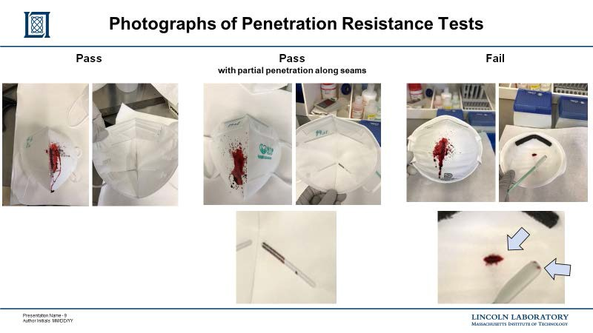

This document will be updated as additional masks and samples are tested