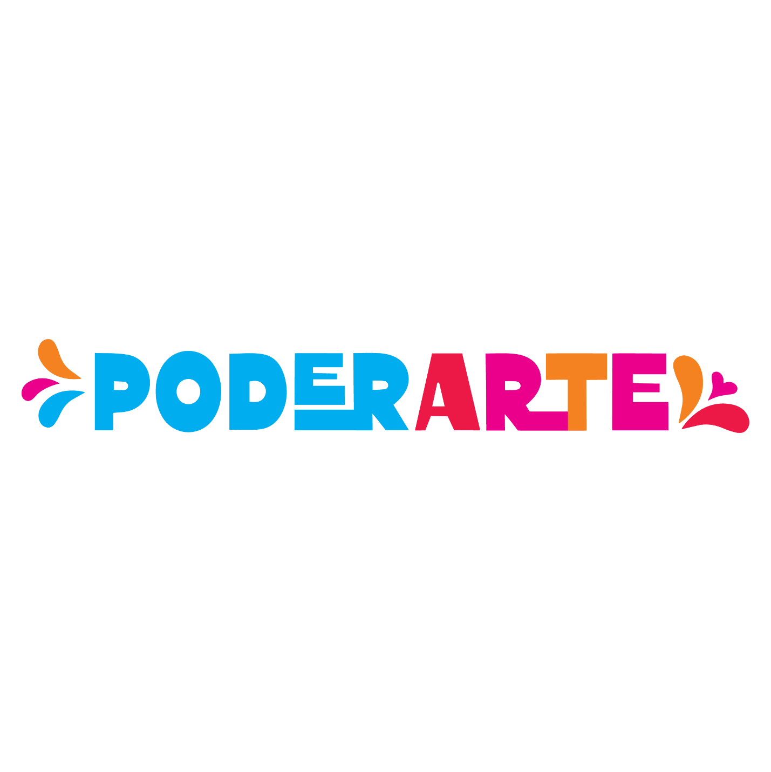
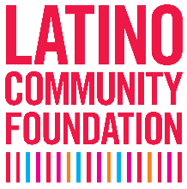
GRANT APPLICATION
NARRATIVE FORM

Civic engagement and social change through arts and culture.

INSTRUCTIONS ON HOW TO USE THIS NARRATIVE FORM:
This form is provided to support you with the submission of your PoderArte Grant Application. All applicants must complete Organization Information (Section I) along with either the Project Level Grant Application (Section II) and/or the Program Level Grant Application (Section III) depending on the grant(s) you are seeking.

This document lists the information and questions that are requested and must be uploaded online as a Word document. Completion of this form is not a substitute for submitting your Online Application by the deadline to be considered for funding.

Application Deadline: March 31, 2023, by 11:59 p.m. PST
Questions? Contact our team at grants@latinocf.org

I.) ORGANIZATION INFORMATION
- Organization Name:
- Current Annual Budget:
- Number of Full-Time Staff:
- Number of people served annually:
- Year Founded:
- Phone Number:
- Latino Led? (Select all that apply):
This question is for LCF’s internal data keeping and the response will not impact your application.
  - My Board is at least 51% Latino
  - My staff is at least 51% Latino
  - The population we serve is at least 51% Latino
  - None of the Above
- Organization Website or Social Media Handle:
- Mission Statement (35 words max):

II.) PROJECT GRANT APPLICATION
Project grants range between $25,000- $50,000

Project Information
- Project Name:
- Describe your project in one sentence:
- Project grant request amount:
- Project’s primary location. Please list between 1-3 zip codes:
- Estimated number of artists who will be paid via this grant:
- Lead artist’s website or Social Media handle. If there is a dedicated site for the project, you may include it here:
- Select the artistic discipline(s) of your project:
___ Dance - contemporary, hip-hop, ballet, folklorico, jazz, tap, house, movement traditions and forms of all cultures
___ Literary Arts - poetry, zine-making, spoken word
___ Media Arts - animation, video, digital photography, film, podcasts, other forms of new media
___ Music - traditional/culturally specific, folk, jazz, hip-hop, punk, classical
___ Theater - devised, original works, playwriting, productions
___ Traditional and Folk Arts - basketry, embroidery, weaving, woodcarving, all others
___ Visual Arts - murals, exhibitions, 3D, photography, sculpture, clay works, curatorial training
___ Other (please describe):

- IF APPLYING AS A COALITION – Please list the lead organization and the members within the coalition. Please leave blank if this does not apply to you.

Project Grant Narrative Questions

Please Answer the Following Questions (Please do not exceed 300 words for each response)

- Tell us about your organization’s mission and long-term vision for your community?

- What is the social change that you hope to achieve with this project? (3 sentences max)

- Why are arts and culture important tools/strategy in achieving this change?

- Describe the project for which you are seeking funding. Please provide details related to the project purpose, expected timeline, design, implementation, and key collaborators.

- Describe how your project aligns with one or more of the Grant Themes listed below. Please include in your response how the project fits into the mission of your organization and how the grant theme advances your long-term vision for your community.
- Narrative Change: advance strength-based narratives that amplify community voice, center cultural strengths and identity, and/or reframe how a community is presented.
- Community Education Campaign: raise public awareness and access to information around local issues that impact community well-being.
- Civic Engagement: spark individual and/or collective civic action that addresses shifts in local, state, and national systems and/or policy, including election participation.

- Describe the community your project serves and highlight your reach and trust within this community. Funded organizations must demonstrate strong, ongoing relationships with communities that fall within the lowest quartile of the California Healthy Places Index and support meaningful engagements with those communities. We are particularly interested in your relationships with diverse and/or historically marginalized communities.

- Please describe your project’s accessibility plans. We are particularly interested in learning how various project aspects (i.e. marketing and outreach, location, and project design) will address barriers to participation and collaboration for artists, culture bearers, community members, and/or key partners.

- Now the fun part, what gets you most excited about this project?

Project Grant Support Materials
In this section of the application, you will be asked to provide the required project budget and samples of prior work. Uploads can be accepted in Word or Excel formats.

- Project Budget: please upload your project budget (Excel only)
Selected projects must allocate at least 72% of awarded LCF funds directly to artist(s)'s fees. Matching funds are not required for this grant. However, if total project expenses are projected to exceed the amount requested from LCF, please list additional income sources and their status in the income section of your budget. You may choose to use this downloadable budget template to complete this section of the application.

- Samples of Prior Work: in one Word document please provide up to three (3) work samples to support your project application.

Guidance for selecting work samples:
- Consider including work samples that are relevant to your proposed project and demonstrate prior experience with related projects. Work samples may include URL links to images, audio, video, published literature, and marketing/PR examples. If access to your work sample is password protected, please provide access.
- For existing or expanding projects, consider incorporating marketing/PR materials with your work samples to highlight your community outreach.

- Fiscal Sponsorship Letter of Agreement (if applicable)
A Letter of Agreement between the fiscal sponsor and the applicant organization must be signed by a representative from both parties and submitted with the application.

III.) PROGRAM GRANT APPLICATION
Program grants range between $100,000 and $150,000

Program Information
- Program Name:
- Describe your program in one sentence:
- Program’s primary location. Please list between 1-3 zip codes:
- Program website or Social Media handle. If there is a lead artist engaged with the program, you may include their website or social media handle here:
- Program grant request amount:
- Estimated number of artists who will be paid via this grant:
- Select the artistic discipline(s) of your program:
___ Dance - contemporary, hip-hop, ballet, folklorico, jazz, tap, house, movement traditions and forms of all cultures
___ Literary Arts - poetry, zine-making, spoken word
___ Media Arts - animation, video, digital photography, film, podcasts, other forms of new media
___ Music - traditional/culturally specific, folk, jazz, hip-hop, punk, classical
___ Theater - devised, original works, playwriting, productions
___ Traditional and Folk Arts - basketry, embroidery, weaving, woodcarving
___ Visual Arts - murals, exhibitions, 3D, photography, sculpture, clay works, curatorial training
___ Other (please describe):

- IF APPLYING AS A COALITION – Please list the lead organization and the members within the coalition. Please leave blank if this does not apply to you.

Program Grant Narrative Questions

Please Answer the Following Questions (Please do not exceed 300 words for each response)

- Tell us about your organization’s mission and long-term vision for your community?

- What is the social change that you hope to achieve with this program? (3 sentences max)

- Why are arts and culture important tools/strategy in achieving this change?

- Describe the community your program serves and highlight your reach and trust within this community. Funded organizations must demonstrate strong, ongoing relationships with communities that fall within the lowest quartile of the California Healthy Places Index and support meaningful engagements with those communities. We are particularly interested in your relationships with diverse and/or historically marginalized communities.

- Describe the established program for which you are seeking funding. Please provide details related to the program’s history, collaborators, implementation, and evaluation.

- Describe how your program aligns with one or more of the Grant Themes listed below. Please include how the grant theme advances the mission of your organization and your long-term vision for your community.

- Narrative Change: advance strength-based narratives that amplify community voice, center cultural strengths and identity, and/or reframe how a community is presented.
- Community Education Campaign: raise public awareness and access to information around local issues that impact community well-being.
- Civic Engagement: spark individual and/or collective civic action that addresses shifts in local, state, and national systems and/or policy, including election participation.

- Please describe your program’s accessibility model. We are particularly interested in learning how various program aspects (i.e. marketing and outreach, location, and program design) will address barriers to participation and collaboration for artists, culture bearers, community members, and/or key partners.

- Please provide a few examples of recent program successes that illustrate the impact of your arts programming.

- Now the fun part, what gets you most excited about this program?

Program Grant Support Materials
In this section of the application, you will be asked to provide the required program budget and samples of prior work. Uploads can be accepted in Word or Excel formats.

- Program Budget: please upload your program budget (Excel only)
The selected program must allocate at least 72% of awarded LCF funds directly to artist(s)'s fees. Matching funds are not required for this grant. However, if total program expenses exceed the amount requested from LCF, please list additional income sources and their status in the income section of your budget. You may choose to use this downloadable budget template to complete this section of the application.

- Samples of Prior Work: in one Word document, please provide up to three (3) work samples to support your program application.

Guidance for selecting work samples:
- Include work samples related to your ongoing program that demonstrate prior activities and impact. Work samples may include URL links to images, audio, video, published literature, and marketing/PR examples. If access to your work sample is password protected, please provide access.
- For existing or expanding programs, consider incorporating marketing/PR materials with your work samples to highlight your community outreach.

- Fiscal Sponsorship Letter of Agreement (if applicable)
A Letter of Agreement between the fiscal sponsor and the applicant organization must be signed by a representative from both parties and submitted with the application.

