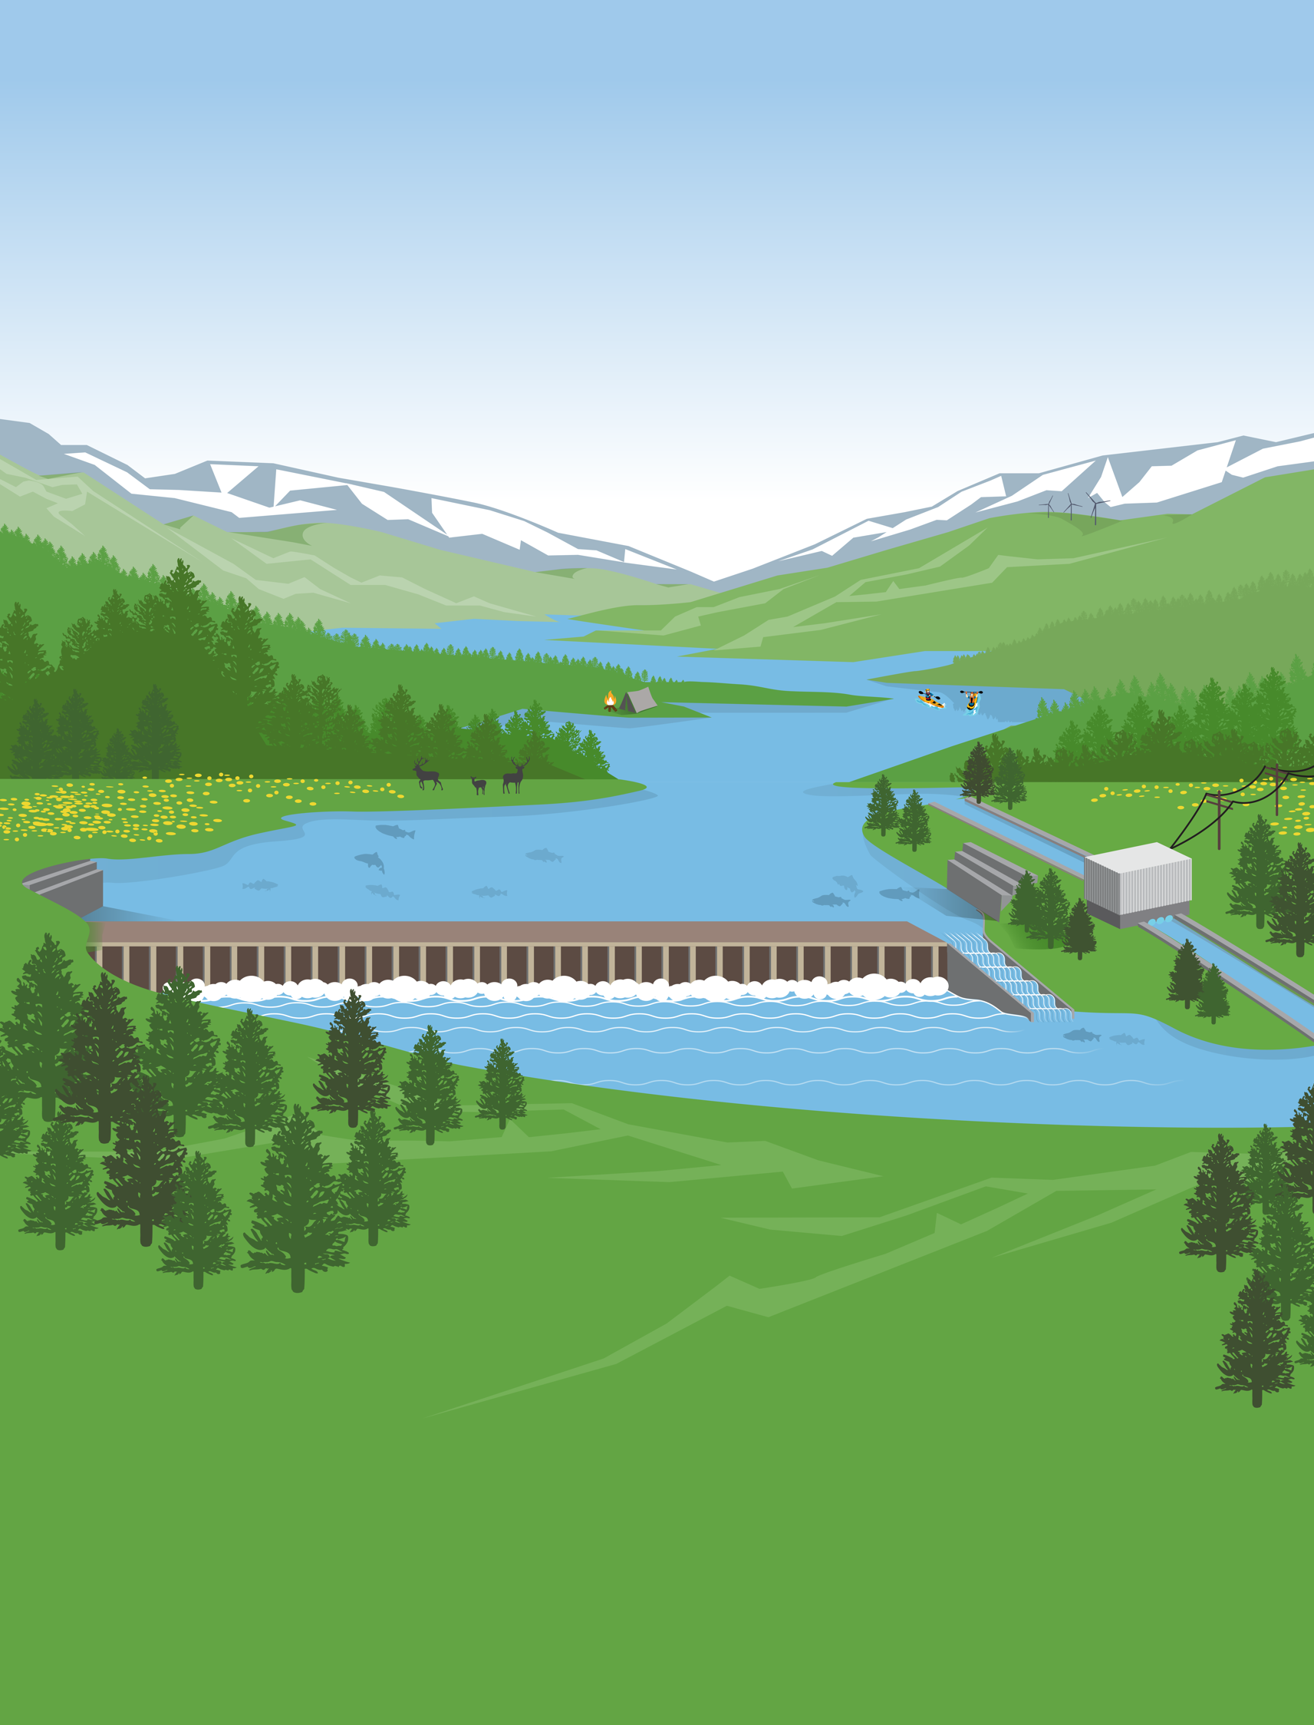
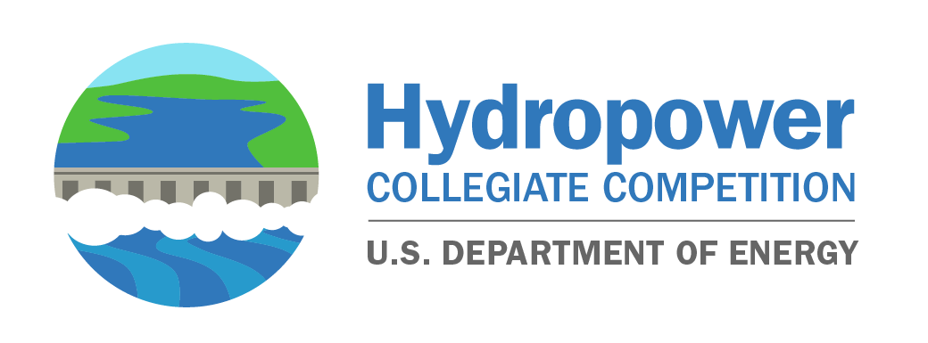
2023 Hydropower Collegiate Competition Application

Accomplishments &
Year End Performance
REPORT ddd Energy Program: Fiscal Year 2021

2023 Application

Hydropower Collegiate Competition 2023 Application
Each application for the U.S. Department of Energy (DOE) Hydropower Collegiate Competition should be a maximum of five pages and include a response for each of the following sections.

Team Contacts
- Lead Institution:
- Partner Institutions (if applicable):
- Collegiate Team Faculty Advisor(s) Name and Department (faculty member or primary representative):
- Faculty Advisor(s) Email:
- Faculty Advisor(s) Phone number:
- Collegiate Team Student Leader(s) Name and Declared/Intended Major (if known):
- Collegiate Team Student Leader(s) Email:

Introduction
- Provide a brief introduction of your team and why you are interested in participating in this competition.

Educational Objectives and Integration (25%)
  - How do you see the competition integrated into the students’ academic experiences? (e.g., courses integrating competition elements or other programs that otherwise support competition-related work, scholarships, independent study projects, or research assistantships designed to support successful student participation in the competition).
  - Alternatively, is there a plan to cultivate required knowledge through other means (e.g., remote learning, industry partnerships, informal independent study projects, industry mentorships, clubs, and so on)?

Organization and Project Planning (25%)
  - Describe how the team will execute elements of the competition, including how unique obstacles, such as academic calendars or virtual collaboration challenges, will be overcome. If applicable, note previous participation in similar competitions.
  - How will the team be supported by faculty and staff to ensure that students can be successful in achieving the competition objectives (e.g., list faculty, staff, and other mentors and how they will advise students throughout the competition)?
  - Which departments across the institution will participate to meet competition requirements?

Team Diversity and Inclusivity (25%)
  - Describe efforts to ensure that team makeup is consistent with DOE’s and the National Renewable Energy Laboratory’s efforts to cultivate a water power workforce comprising diverse backgrounds, skill sets, and educational training. For example:
    - Describe how team members of diverse or unique backgrounds will be engaged and recruited to ensure team diversity.
    - Describe how the team will successfully incorporate the multiple academic disciplines to meet competition requirements.
    - List and justify resources (e.g., software, educational materials, project planning tools, and so on) organizers could provide to help fill any identified gaps.

Institutional Support and Fundraising (10%)
  - $10,000 will be provided per team by the National Renewable Energy Laboratory. These funds may not cover the full expenses of this project or participation for all students. What is your planned approach to acquire additional funds, if needed (e.g., grants, fundraising, or direct institutional funding commitment)?

Communications and Outreach (15%)
  - Demonstrate ability and willingness to participate in the competition’s outreach activities and to cultivate the spirit of the competition in the broader community. Outline actions you may take to actively engage with the local or campus media, the student body, the community, or local K-12 schools about the team’s participation in the competition through social media, blog posts, and other outlets.

