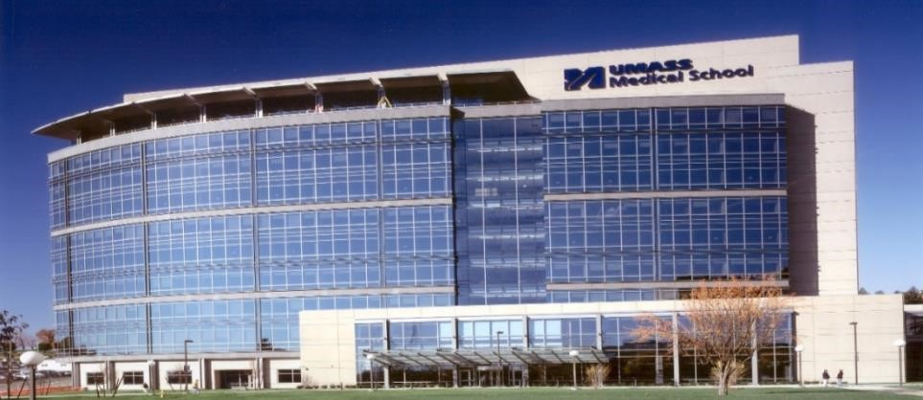 TEACHING OF TOMORROW

A Faculty Development Program

Teaching of Tomorrow (TOT) is a nationally recognized and highly acclaimed Faculty Development Program

For over 25 years, UMass Chan faculty from the departments of Family Medicine and Community Health, Internal Medicine, and Pediatrics have trained over 1,800 clinical faculty and preceptors in many disciplines across the country. TOT focuses on building and refining foundational skills for effective clinical teaching in inpatient and ambulatory settings. Preceptors from any specialty and discipline will enhance their clinical teaching skills through discourse and practice.

TOT also provides valuable opportunities to network with other clinician educators. Our award-winning interprofessional faculty utilize the principles of adult learning, drawing on participants’ experience and building knowledge through dialogue. The engaging conference provides frequent opportunities to practice and assess new skills in a safe and fun environment.

Accreditation:
CME credits are granted by the
American Academy of Family Physicians (and accepted by organizations such as AAPA, ANCC, NCCPA, and AANPCB).

Program Goals:
- Ignite and share a passion for teaching
- Develop practical teaching skills for effective and efficient teaching in the clinical setting
- Provide practice opportunities to apply and assess new teaching skills.

Format and Description:
- A total of 4 days of training: two, 2day in-person conferences, beginning Friday morning and ending Saturday afternoon.
- This event is to encourage participation of teachers from across the country.
- The learning sessions alternate between brief, large group didactics and small groups, which include application of new skills and case and problem-based learning.

Topics include:
- Characteristics of good teachers
- Conducting needs assessments
- Writing and implementing learning objectives
- Effective and efficient teaching methods
- Feedback and evaluation
- Challenging educational interactions
WWW.UMASSMED.EDU/CFDC

Audience:
- Clinical educators–MDs, DOs, NPs,
PAs, RNs, Behavioral Health,
Pharmacists
- Primary care and specialty providers
- Teachers of students, residents, and advanced learners.
- Teachers in both in-patient and ambulatory settings.

Dates and Location:
The 2023-2024 Conference:
- Session 1 – November 17-18, 2023
- Session 2 – March 8-9, 2024
Attendance is required at both sessions

Location:
Hotel Northampton Northampton, MA http://www.hotelnorthampton.com

Registration Cost:
$1650 per participant
(UMass employee discount may be available, contact susan.foley@umassmed.edu) Includes all session materials and CMEs.

Register before October 25th Deadline:

University of Massachusetts Chan Medical School
Clinical Faculty Development Center / Family Medicine and Community Health
55 Lake Avenue North, Worcester, MA 01655 Tel. (774) 442-6784

